1. Open design manager
2. Click on Edit Master Pages
3. Click on “[Convert an HTML file to a SharePoint master page](javascript:%7b%7d)”

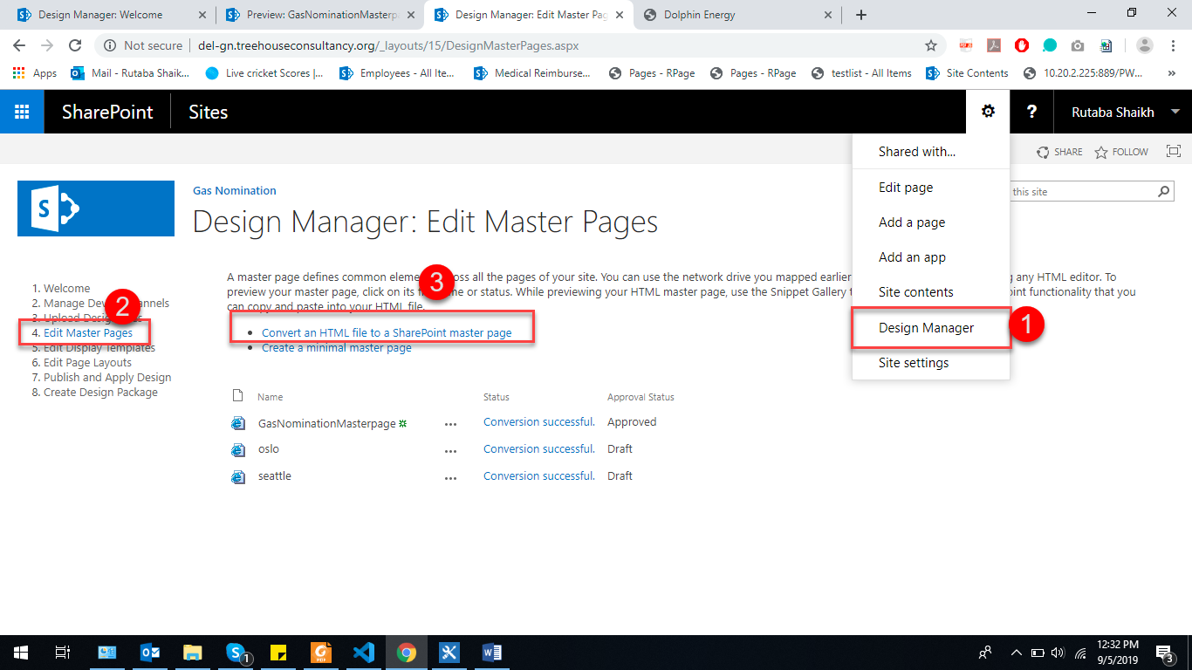

1. Click on add new item

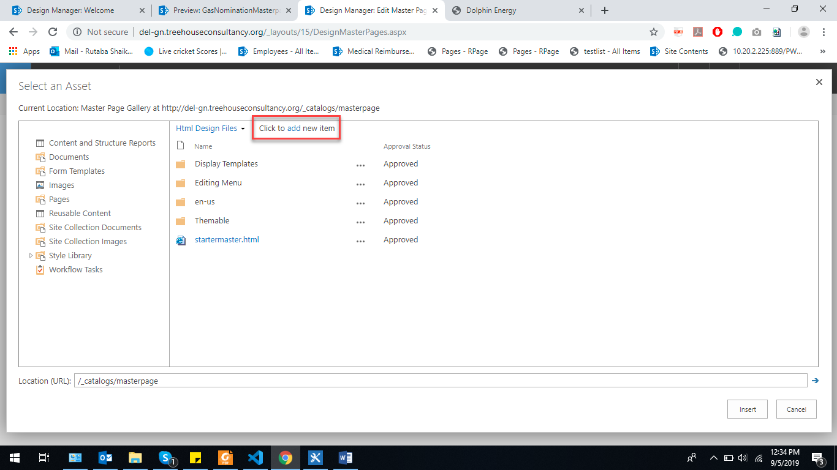

1. Choose file from your desktop

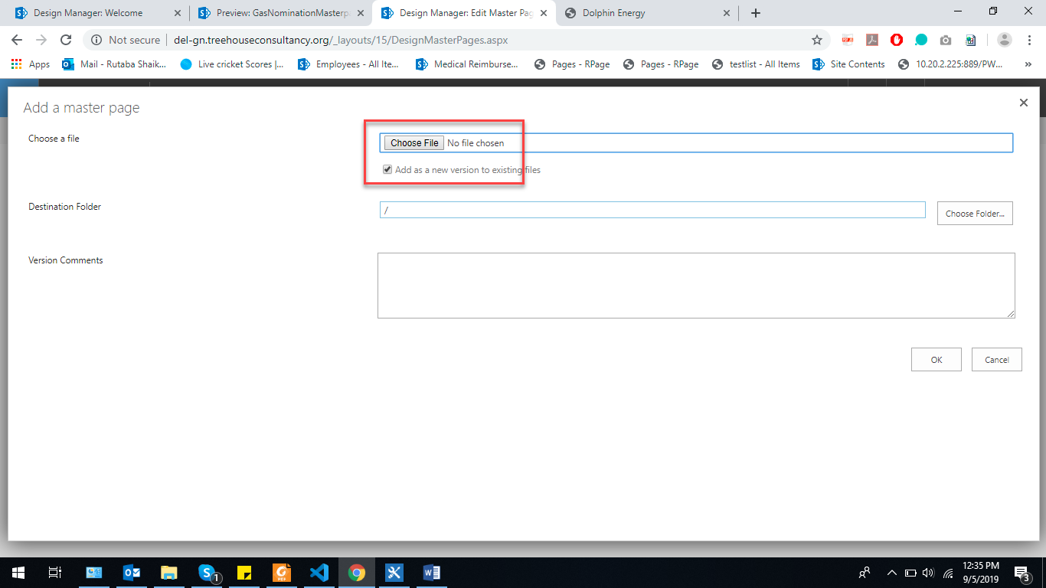

1. Choose HTML Master Page

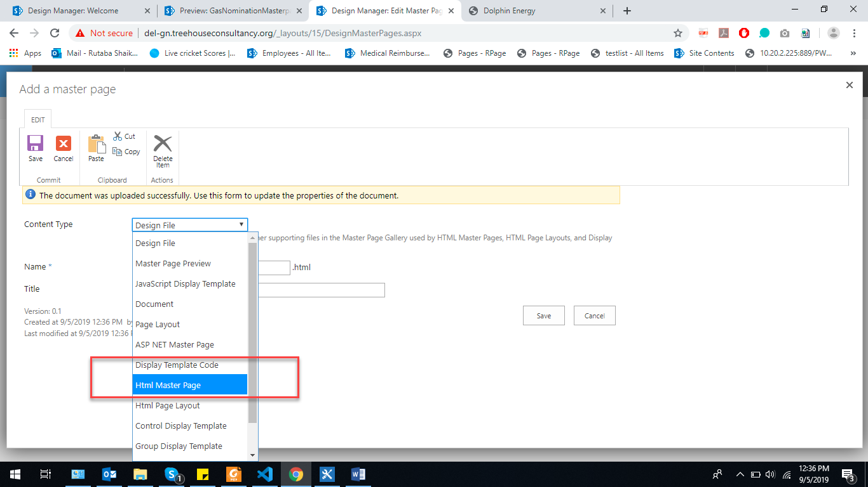

1. Also click HTML Master page from here and press save button.

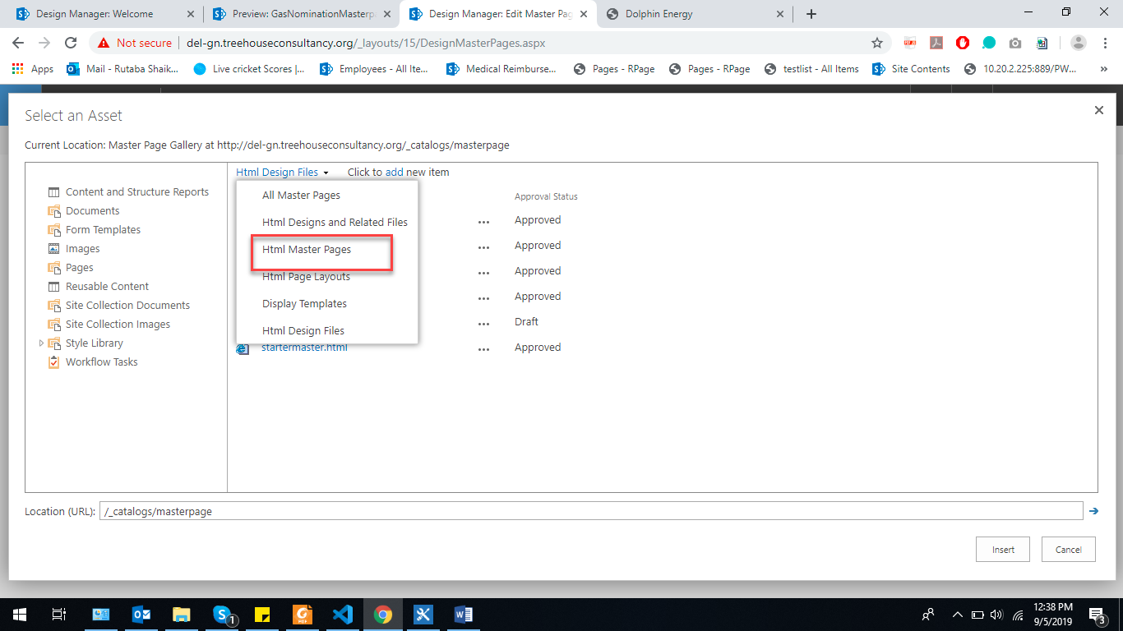

1. Publish this page so sharepoint could put its tag in your file by clicking 3 dots again 3 dots >>advanced>>publish major version
2. Open your file in sharepoint designer and move yellow div from bottom to center (yellow div: where your content will be shown). Following is final result.

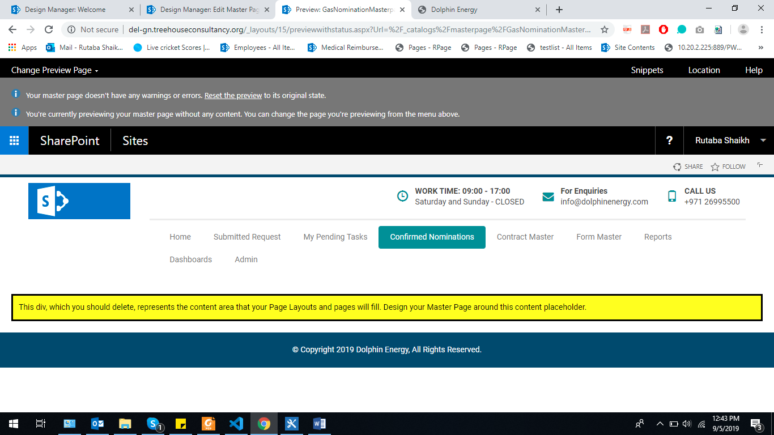

1. Click on snippets. Following screen wl be shown and click on site logo then site logo appears

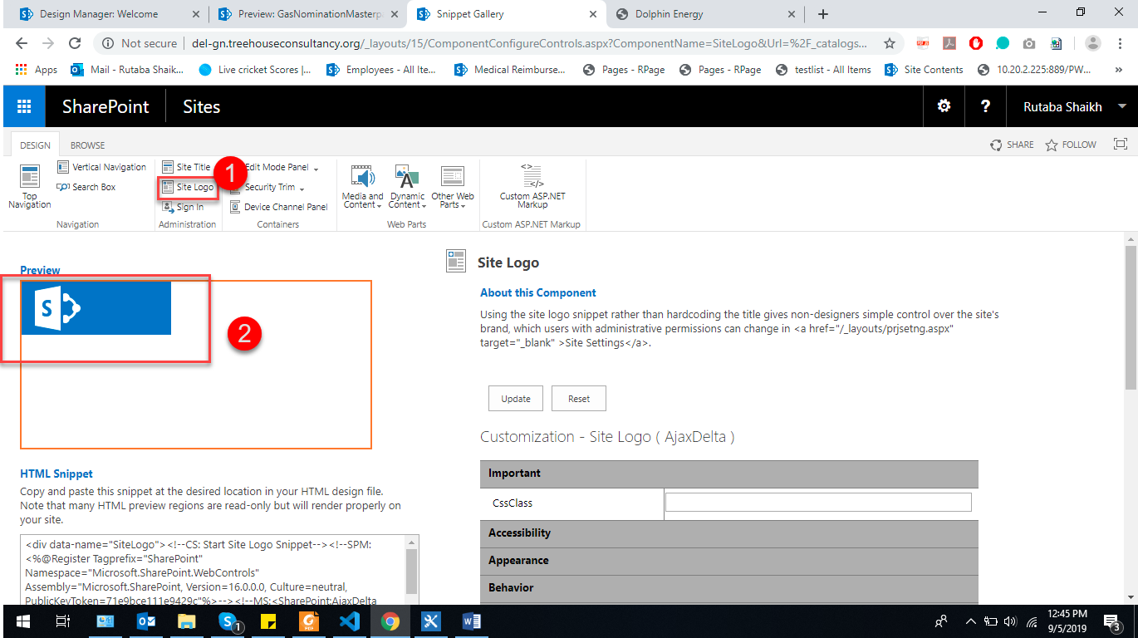

1. Scroll down little and copy the html of logo in your file to put logo

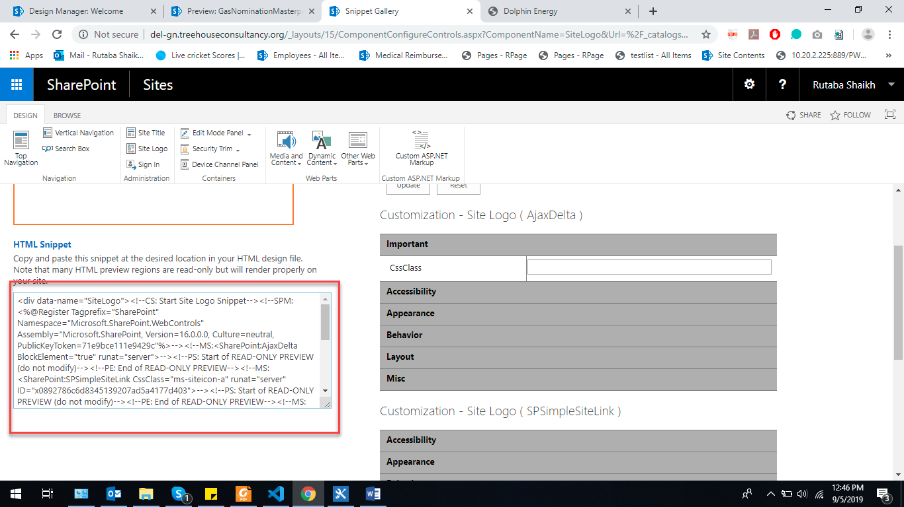

1. As I have out html in a div

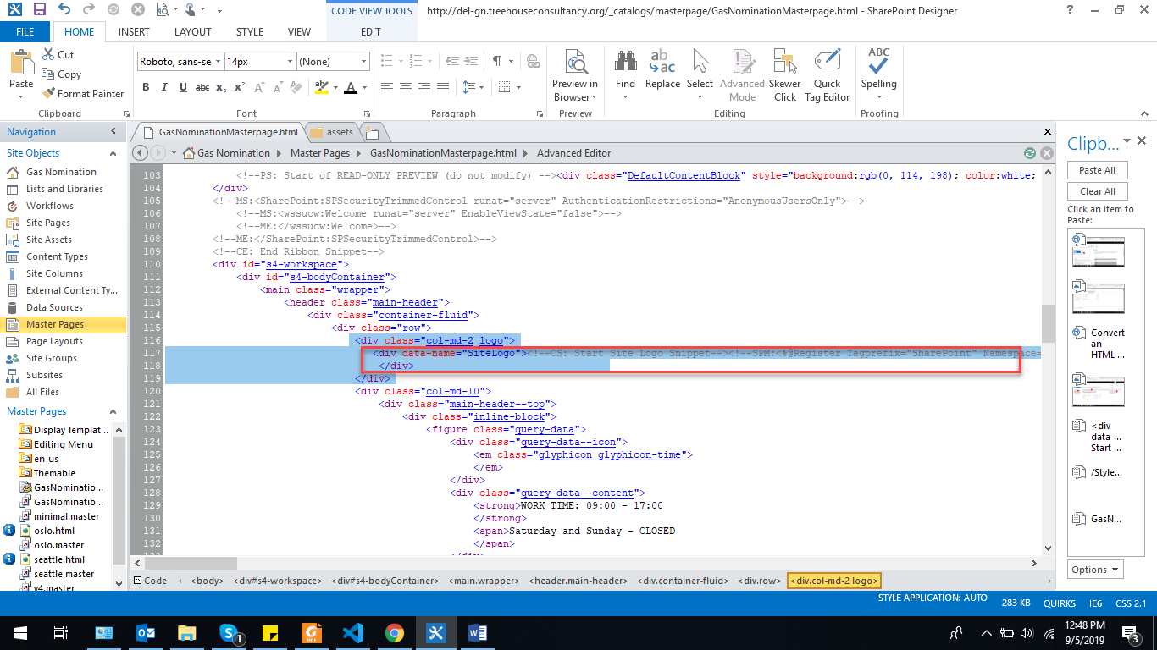

1. Here is your logo.. after it publish your page

